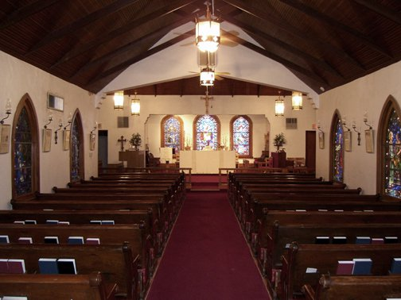
St Luke’s Episcopal Church
Serving the Upper Valley with healing and hope since 1916.
St. Luke’s Country Fair
Saturday, October 5, 2019
Fair Hours: 11 am – 6 pm
Set up starting at: 8:00 am

Name ________________________________________________________________________________
(Your name, what you are called)

Business Name _______________________________________________________________________
(What your business is called)

Address _____________________________________________________________________________
(Address, City, State, Zip Code)

Type ________________________________________________________________________________
(What do you sell?)

Email ________________________________________________________________________________
(So we can stay in touch. We do not give out your information to anyone else.)

Home Phone __________________________Cell Phone ______________________________________
(Must have message capabilities.)

The booths are a space measuring 10 feet by 10 feet. You supply the covering, tables, chairs, etc. Be sure to check the correct space below if you need electrical power.

PAY BY CHECK: Please print, complete and attach your check payable to:

St.Luke’s Episcopal Church]
7050 McNutt Road, La Union, NM 88021
Or
PAY BY CREDIT CARD: Return this form to STLUKESLAUNIONOFFICE@GMAIL.COM then go to our website STLUKESLAUNION.ORG, click on donate and use the drop down box for Country Fair. Confirmation emails will be sent by Friday.

Booth (No Electricity) | Booth (Yes Electricity) | Non-Profit Community Service
$50.00 Check here __________ | $55.00 Check here ___________ | Free Check here __________
Early Bird Price | Early Bird Price | Ends August 31 2019
$30.00 | $35.00
******************************No refunds after September 30,2019****************************
Jane Cave, Vendor Chairman, (505)280-8263 Email: STLUKESLAUNIONOFFICE@GMAIL.COM

